# Master slave configuration,Node Level

Step’s

**:** Logon to Jenkins

**:** Manage Jenkins 🡪 Manage Nodes and Clouds

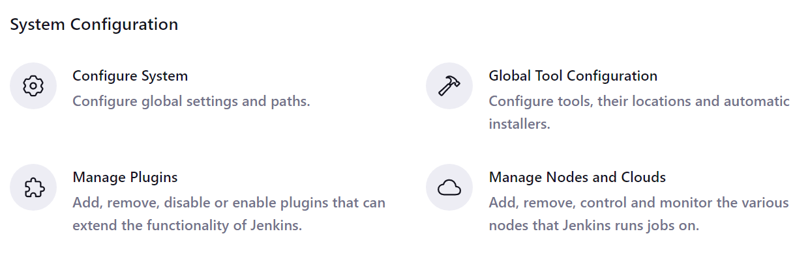

: Create New node

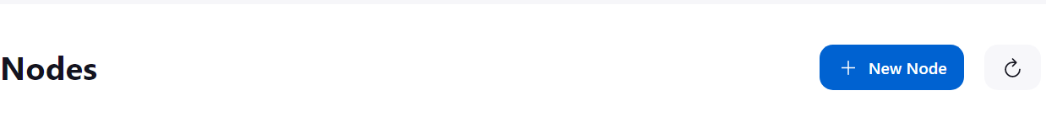

: Give the node name and selected as a Permanent Agent

: Select number of Executors you want



: Provide the IP address of the slave machine in Remote root directory

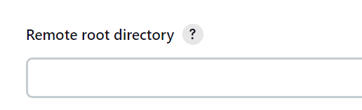

: Give the lable name to identify the node’s

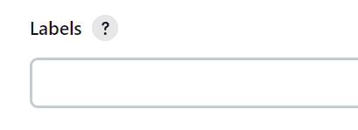

: Usage of node

* Select Use this node as much as possiable

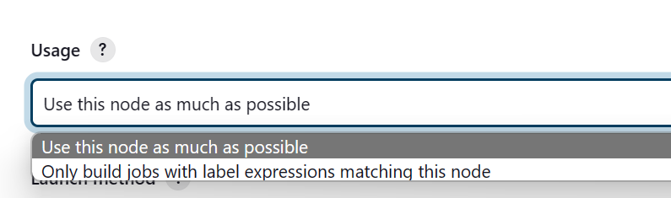

: Launch Method

* Select Launch agents via SSH

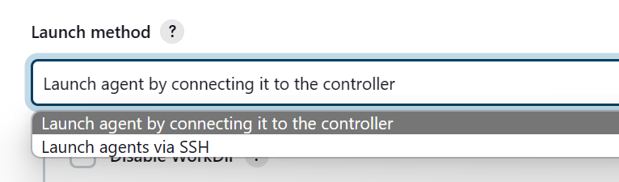

:

* Provid the Ip address of your slave machine
* 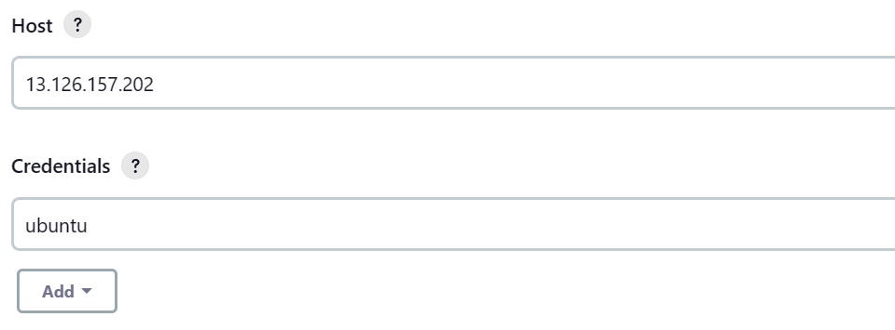

: Create a Credentials with Jenkins

* Select Domain as “ Global Credentials(unrestricted)”
* Select Kind as “ SSH username with Private key
* Scope as it is
* Provide ID
* Give Username of your slave machine
* IN private key
  + - 1. Select ADD to add the private key
* Private key is your Slave machine .pem file
  + - * Open pem file in Notepad copy the content .
      * Add it to here
      * 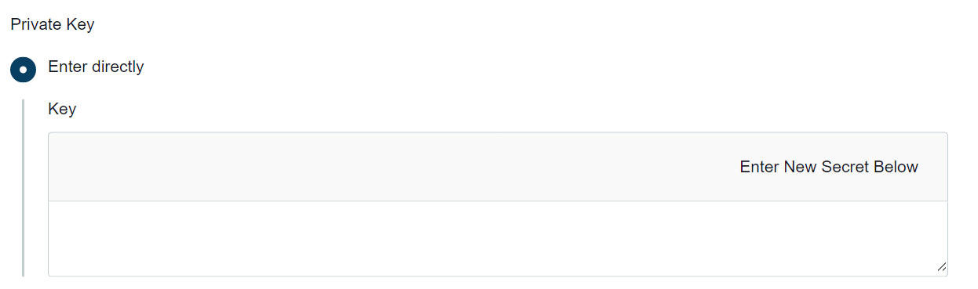

: Host Key Verification Strategy

* Select Manually Trusted Verification Strategy

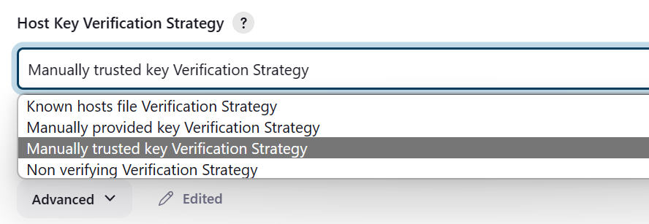

: Availability

* Select Keep this agent online as much as possible.

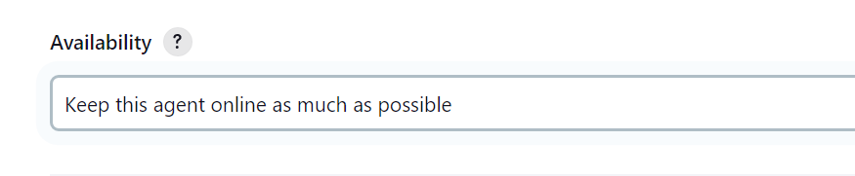

: Save the Node

## In your master machine

: Generate the ssh key

By using the command ssh-keygen

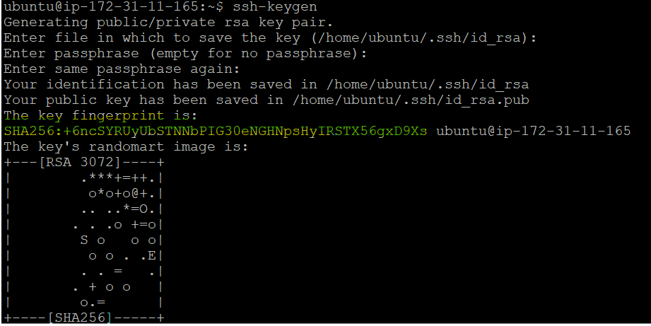

: Copy the key and past it in your slave machine Authorized key

* /home/ubuntu/.ssh
* Open Authorized key and past the key in it.

: Now Create a Job in Jenkins and run that job in your salve machine